

*Operating Lease Support System Phase-2 Project*

*for*



***Functional Specification FC.AD.2.6***

***Monitor Under Maintenance of Unit***

Revision 1.0

**PT. Berlian Sistem Informasi**

KTB Annex Bld. 4th Floor, Jl. Jend. A. Yani. Pulomas,

Tel. +62 21 4786 7575 (Hunting) Fax. +62 21 4714964 www.bsi.co.id

Document Control

|  |  |
| --- | --- |
| **Author** | Dimas Oktarianto |
| **File Name** |  |
| **Path** |  |
| **Number of Pages** |  |

Revision History

|  |  |  |  |
| --- | --- | --- | --- |
| **Date** | **Revision** | **Description** | **Author** |
| 23/12/2015 | 0.0 | Initial Creation | Dimas Oktarianto |
| 04/01/2016 | 0.1 | QCO Review :   * Revise Distribution List and Document Approval | Dimas Oktarianto |
| 12/01/2016 | 1.0 | 1st Baseline | Dimas Oktarianto |

Distribution List

|  |  |  |
| --- | --- | --- |
| Name | Organization | Roles |
| Mr. Yutaro Sanada | Dipo Star Finance, PT | DSF Project Director |
| Mr. Shinji Hosokawa | Dipo Star Finance, PT | DSF Project Advisor |
| Mr. Ahmad Fikri | Dipo Star Finance, PT | DSF Project Advisor |
| Mr. Abdul Somad | Dipo Star Finance, PT | DSF Project Manager |
| Mr. Delta Riangga | Dipo Star Finance, PT | DSF Key User |
| Mr. Mochamad Idris | Dipo Star Finance, PT | DSF Key User |
| Mrs. Herni Hembang | Dipo Star Finance, PT | DSF Key User |
| Mr. Junaidi Didy | Dipo Star Finance, PT | DSF Key User |
| Mr. Dedi Supriyadi | Dipo Star Finance,PT | DSF Key User |
| Mrs. Elke Hilviana | Dipo Star Finance,PT | DSF Key User |
| Mr. Mukhlis Ibrahim | Dipo Star Finance, PT | DSF IT Department Representative |
| Mr. Roby Wijaya | Dipo Star Finance, PT | DSF IT Department Representative |
| Mr. Daiki Kamada | Berlian Sistem Informasi, PT | BSI Project Director |
| Mr. Feri Irawan | Berlian Sistem Informasi, PT | BSI Project Advisor |
| Mr. Grand Zah Putra | Berlian Sistem Informasi, PT | BSI Project Manager |
| Mr. Dimas Oktarianto | Berlian Sistem Informasi, PT | BSI Business Analyst |

Document Approval

By signing this document I acknowledge I have read the document and give the Project Management Team approval to proceed.

|  |  |  |  |
| --- | --- | --- | --- |
| Role | Name | Signature | Date |
| DSF Project Director | Mr. Yutaro Sanada |  |  |
| DSF Project Director | Mr. Shinji Hosokawa |  |  |
| DSF IT Advisor | Mr. Shinya Tsukamoto |  |  |
| DSF IT Advisor | Mr. Ahmad Fikri |  |  |
| DSF PMO | Mr. Roby Wijaya |  |  |
| DSF DSF Biz. Operation Leader | Mr. Abdul Somad |  |  |
| DSF IT Operation Leader | Mr. Mukhlis Ibrahim |  |  |
| BSI Project Director | Mr. Daiki Kamada |  |  |
| BSI Project Manager | Mr. Grand Zah Putra |  |  |
| BSI Technical Leader | Mr. Raymond |  |  |
| BSI Business Analyst | Mr. Dimas Oktarianto |  |  |

Table of Contents

Document Control 2

Revision History 2

Distribution List 3

Document Approval 4

1 Introduction 6

1.1 Purpose 6

1.2 Scope 6

1.3 Definitions, Acronyms, and Abbreviations 6

1.4 References 6

2 Configuration 6

3 Process Specification: AD.2.6 Monitor Under Maintenance of Unit 7

3.1 Purpose 7

3.2 Screen of Configuration Access 7

3.3 Screen Functionality 7

3.4 Operation Flow 7

3.5 Screen Detail 8

3.6 Screen Functionality 9

3.7 Operation Description 11

3.8 Data Structure 15

3.9 Screen Item List 16

3.10 Entity Relationship Diagram 18

1. Introduction
   1. Purpose

Functional Specification is a document to describe the detail of functions system which includes screen design and logic formula. This document will be used for system development.

* 1. Scope

Functional Specification Document contains screen design, screen functionality, process flow, and data structure of AD.2.6 Monitor Under Maintenance of Unit.

Here are the scope for AD.2.6 Monitor Under Maintenance of Unit :

1. **AD.2.6.1 View List of Maintenance Agreement**

To view List Maintenance of Unit based on Agreement, Purchase Order, and Unit Management.

1. **AD.2.6.3 Update Status**

To Update Status for under maintenance unit.

1. **AD.2.6.4 Update Status Set to Completed**

To Update Status to complete for under maintenance unit.

1. **AD.2.6.6 Print**

To Print Under Maintenance Report.

Output from this function is :

1. RPT.AD.2.1. Report Under Maintenance Unit
   1. Definitions, Acronyms, and Abbreviations

List of definitions that are used in this document :

1. WO = Work Order.
2. MU = Maintenance Unit.
3. OPL = Operating Lease.
4. BAST = Berita Acara Serah Terima / Handover Report.
   1. References

This functional specification document refers to **“To Be Design” BSI Unit/ Vehicle Maintenance Process**, module:

1. AD.2.6 Monitor Under Maintenance of Unit.
2. Configuration

N/A

1. Process Specification: AD.2.6 Monitor Under Maintenance of Unit
   1. Purpose

Screen of Monitor Under Maintenance of Unit will be used by PIC Maintenance to monitor unit when under maintenance. This Screeen Function consist of View list of maintenance agreement, view under maintenance, Update Status, and print Under Maintenance of Unit.

This function covered by **“Monitor Under Maintenance of Unit”** screen.

* 1. Screen of Configuration Access

Here are the access right for **“Monitoring Unit Preparation”** screen users:

|  |  |  |  |  |
| --- | --- | --- | --- | --- |
| ***User*** | ***Create*** | ***Read*** | ***Update*** | **Authorization** |
| PIC Maintenance | - | V | V | V |
| Admin | - | V | - | V |

Legend : V = have the acess

Note:

1. Create. related to create schedule
2. Read: related to read display list of view list of maintenance agreement.
3. Update: update status of under maintenance unit.
4. Authorization: related to access screen.
   1. Screen Functionality
5. View List of Maintenance Agreement.
6. Update Status.
7. Update Status set to completed.
8. Print Under Maintenance of Unit.
   1. Operation Flow

Below is operation flow for Monitoring and print unit preparation process refer to **To Be Design Document Unit/ Vehicle Maintenance**, AD.2.6. Monitor Under Maintenance of Unit:

|  |  |
| --- | --- |
| **PIC PC** | **Process** |
|  | D:\maintenance_agreement\Last\UnderMaintenance.JPG  Note:  Source  Output & Input    Under Maintenance  (TB\_MTN\_UnderMT)  WO Number  (Tb\_MTN\_WorkOrder)  Monitoring Schedule  (Tb\_MTN\_Monschdl) |

* 1. Screen Detail
* Screen design of ‘List of under maintenance unit’, which will be used as an initial screen for Monitoring under maintenance of unit and also is used as input and update status for under maintenance Unit

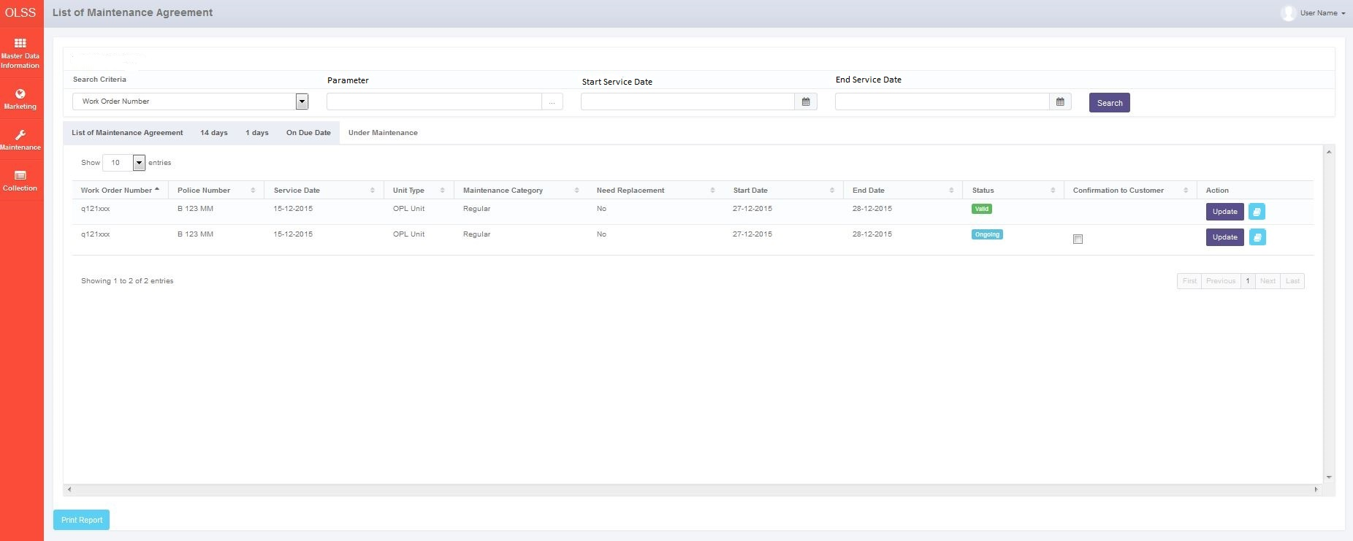

*Screen 1. List of Under Maintenance of Unit*

* Screen design of “Pop up under maintenanance”, which will be used as screen for update status and save the changes.

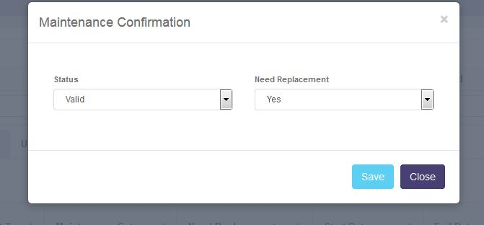

*Screen 2. Pop up Maintenance Confirmation*

* 1. Screen Functionality

Here are the screen functions from each component in Monitor Under Maintenance of Unit screen:

|  |  |  |  |
| --- | --- | --- | --- |
| ***No*** | ***Component*** | ***Name*** | ***Function*** |
| **Header** | | | |
| 1. | Label | List of Maintenance Agreement | To display List of Maintenance Agreement. |
| **Search Criteria** | | | |
| 2. | Drop down box | Search Criteria | To Select Category for searching maintenance data |
| 3. | Text Field | Parameter | To input parameter for searching maintenance data |
| 4. | Date Picker | Start Service Date | To input start service date based on update date when submit maintenance data |
| 5. | Date Picker | End Service Date | To input end service date based on update date when submit maintenance Data |
| 6. | Button | Search | To search maintenance data based on selected criteria |
| **Under Maintenance** | | | |
| 7. | Tab | Under Maintenance | To display List Under Maintenance. |
| 8. | Label | Work Order Number | To display work order number. |
| 9. | Label | Police Number | To display Unit Police Number. |
| 10. | Label | Service Date | To display service date. |
| 11. | Label | Unit Type | To display unit type. |
| 12. | Label | Maintenance Category | To display Maintenance Category. |
| 13. | Label | Need Replacement | To display Need Replacement. |
| 14. | Label | Start Date | To Display start service date. |
| 15. | Date | Start Date | To Pick start service date. |
| 16. | Label | End Date | To Display End Service Date. |
| 17. | Date | End Date | To Pick end service date |
| 18. | Label | Status | To display status under maintenance. |
| 19. | Text Field | Status | To set status under maintenance. |
| 20. | checkbox | Confirmation to Customer | To check unit has comeback to customer. |
| 21. | Label | Action | To display Action Button |
| 22. | Button | Update | To Update status and need replacement |
| 23. | Button | Submit | To Submit Maintenance Cost. |
| 24. | Label | Showing N to M of X entries | Displaying Maintenance data sequence and the total of maintenance data. |
| 25. | Link | First Page | To display first entries page of under maintenance data |
| 26. | Link | Previous Page | To display the previous entries page of under maintenance data. |
| 27. | Link | Page Number | Displaying the page numer of the list. |
| 28. | Link | Next Page | To display the next entries page of maintenance data. |
| 29. | Link | Last Page | To show the last page entry. |
| **Footer** | | | |
| 30. | Button | Print Report | To Print report under maintenance. |

Here are the screen functions from each component in Pop Up Maintenance Schedule Creation screen :

|  |  |  |  |
| --- | --- | --- | --- |
| ***No*** | ***Component*** | ***Name*** | ***Function*** |
| **Header** | | | |
| 1. | Label | Maintenance Confirmation | Update Under Maintenance title |
| **Update Maintenance Agreement** | | | |
| 2. | Label | Status | To display Status |
| 3. | Dropdown Box | Status | To Select Status under maintenance |
| 4. | Label | Need Replacement | To display Need Replacement |
| 5. | Dropdown Box | Need Replacement | To Select Replacement |
| **Footer** | | | |
| 6. | Button | Save | To save the update |
| 7. | Button | Close | To Close Pop Up |

* 1. Operation Description

|  |  |  |
| --- | --- | --- |
| **No.** | **Operation Name** | **Description** |
| 1 | Initial view of List of Under Maintenance Unit | The screen tab for List of Under Maintenance Unit:   1. Component Status;  |  |  |  |  | | --- | --- | --- | --- | | Component | Name/Caption | Status | Remark | | Label | Monitor Under Maintenance | Active |  | | Button | Search Criteria | Active |  | | Field Text | Param | Active |  | | Date Picker | Start Period | Active |  | | Date Picker | End Period | Active |  | | Button | Search | Active |  | | Drop down box | Show Entries | Active | As initial by default number of show entries list that will be display is 10 | | Label | Work Order Number | Not Active |  | | Label | Work Shop | Not Active |  | | Label | Work Shop Location | Not Active |  | | Label | Police Number | Not Active |  | | Label | Service Date | Not Active |  | | Label | Unit Type | Not Active |  | | Label | Maintenance Category | Not Active |  | | Label | Need Replacement | Not Active |  | | Label | Start Date | Not Active |  | | Date | Start Date | Not Active |  | | Label | End Date | Not Active |  | | Date | End Date | Not Active |  | | Label | Status | Not Active |  | | checkbox | Confirmation to Customer | Active | Active when status set to completed | | Label | Action | Not Active |  | | Button | Update | Active |  | | Label | Showing N to M of X entries | Not Active |  | | Link | Firs Page | Active | Active depending on the current entry | | Link | Previous Page | Active | Active depending on the current entry | | Link | Page Number | Not Active |  | | Link | Next Page | Active | Active depending on the current entry | | Link | Last Page | Active | Active depending on the current entry | | Button | Print Report | Active |  | |  |  |  |  | |
| 2 | Display List of Under Maintenance Unit | Input:   1. Access menu OLSS 2. Select menu Maintenance 3. Select sub menu view list of maintenance agreement 4. Select Tab Under Maintenance 5. Select number of show list entries : 10, 25, 50, and 100 6. PIC Maintenance click button submit at field action to input maintenance cost on service history inquiry screen.       Process:   1. System will displays data on List of Under Maintenance Unit based on due date service maintenance in ascending order. 2. The list will displayed based on due date service. 3. Data that will be displayed are Unit Under Maintenance data with data based on the Tb\_MTN\_Monschdl (PoliceNumber, ServiceDate, UnitType, MaintenanceCategory, StartDate, EndDate), Tb\_MTN\_WorkOrder (WorkOrderNum). 4. Based on **Screen 1. Under Maintenance Unit**, informations related to Under Maintenance Unit that will be displayed automatically are: 5. Work Order Number. 6. Police Number 7. Service Date 8. Unit Type 9. Maintenance Category 10. Start Date 11. End Date 12. System will display data row based on selected show number entries   Output:   1. Display list of all Units when under maintenance based on due date service maintenance in ascending order.   Alternative:  N/A |
| 3 | Searching List of Maintenance Agreement at List of Maintenance Agreement | Input:   1. Access menu OLSS 2. Select menu Maintenance 3. Select sub menu view list of maintenance agreement. 4. Select tab under maintenance. 5. Select Search Criteria Drop down boxand click among these:  |  |  | | --- | --- | | **Criteria Searching** | **Constraint Input** | | Work Order Number | varchar | | Police Number | varchar | | Service Date | varchar | | Unit Type | varchar | | Maintenance Category | varchar | | Need Replacement | varchar | | Start Date | Date | | End Date | Date | | Status | varchar | | Schedule Date | Date |  1. Select Start and End date period to filter based on the service date, start date, end date.   Constraint :   * 1. End Period can not be less than Start Period (the End Period will be locked for the date before Start Date).   2. Start Period can not be less than End Period (the Start Period will be locked for the date after End Date)  1. Click Search button 2. Select number of show list entries : 10, 25, 50, and 100     Process:   1. User can only choose one search criteria to be searched 2. When user click search button, system will displays data on List of Maintenance Agreement based on the selected criteria searching. Formula: 3. If user input Criteria Searching, Criteria Searching param, Start Date, and End Date period, system displays data based on selected criteria searching on selected range end contract, Last Service, Schedule Date. 4. If user input both of Criteria Searching, Criteria Searching param and Start Date, system displays data based on selected criteria searching start from selected Schedule Date until the latest Schedule date. 5. If user input both of Criteria Searching, Criteria Searching param and End Date, system displays data based on selected criteria searching start from the oldest Schedule date until selected update date. 6. If user input Criteria Searching and its param only, system displays all of the list of maintenance agreement data based on the criteria searching only. 7. Data that will be displayed are data based on the newest Maintenance agreement date (TB\_MTN\_UnderMT) 8. Based on **Screen 1. Under Maintenance Unit**, informations related to Under Maintenance Unit that will be displayed automatically are: 9. Work Order Number. 10. Police Number 11. Service Date 12. Unit Type 13. Maintenance Category 14. Start Date 15. End Date 16. System will display data row based on selected show number entries   Output:   1. Display list of all Maintenance Agreement data based on the search result service date in ascending order.   Alternative:  N/A |
| 4 | Print Report | Input:   1. Access menu OLSS 2. Select menu Maintenance 3. Select sub menu view list of maintenance agreement 4. Select Tab Under Maintenance Unit 5. Select Search Criteria Drop down box and click among these:  |  |  | | --- | --- | | **Criteria Searching** | **Constraint Input** | | DSF Office | Varchar | | Unit Type | Varchar | | Agreement Number | Varchar | | Police Number | Varchar | | Maintenance Type | varchar | | Maintenance Category | varchar | | End Contract | Date | | Last Service | Date | | KM | Number | | Schedule Date | Date | | Maintenance Budget | Number | | Overdue | Number |  1. Select Start and End date period to filter based on the Schedule Date.     Constraint:   * 1. End Period can not be less than Start Period (the End Period will be locked for the date before Start Date)   2. Start Period can not be less than End Period (the Start Period will be locked for the date after End Date)  1. Click Search button . 2. Click Print Report button     Process:   1. User can view list of maintenance agreement data which will be printed, in list of under maintenance search result list. 2. Informations related to Maintenance that will be printed are: 3. Work Order Number. 4. Police Number 5. Service Date 6. Unit Type 7. Maintenance Category 8. Start Date 9. End Date 10. Maintenance data will be sorted based on Maintenance date service at Maintenance Report   Output:   1. Printed list of all Maintenance data based on the Maintenance search result   Alternative:  N/A |
|  | Input and update status for under maintenance unit | Input:   1. Access menu OLSS 2. Select menu Maintenance 3. Select sub menu List of Maintenance 4. Select tab under maintenance. 5. Select update button. To update status and need replacement for under maintenance     Constraint   * 1. Pop up shown after PIC Maintenance click update then PIC Maintenance can Update status and need replacement for under maintenance.      * 1. The PIC must confirm to workshop about maintenance unit based on their schedule date and also needed for replacement.  1. Click Save button to save the new status under maintenance and after status completed PIC Maintenance will ask customer to make sure unit already in customer.     Process:   1. System will shorting data by date on due date in ascending order. 2. Data that will be displayed are data based on the Tb\_MTN\_WorkOrder, Tb\_MTN\_UnderMT, Tb\_MTN\_Monschdl. 3. PIC Maintenance check status unit. 4. PIC Maintenance click update button to update status unit under maintenance, and also Confirmation to workshop if unit need replacement. Click save, After save there will be notification shown “**Success ! Under Maintenance List has been updated**”. 5. Start Date and End Date update will update table on asset management modul Tb\_MGT\_UnitStatusLoc on field start and estimation, after status under maintenance set to completed it will updated field end date on Tb\_MGT\_UnitStatusLoc. 6. Based on **Screen 1. List Under Maintenance**, informations related to Maintenance Agreement that will be displayed automatically are:    1. Work Order Number ( source : Tb\_MTN\_WorkOrder.WorkOrdernum )    2. Police Number ( source : Tb\_MTN\_Monschdl.PoliceNumber )   Service Date ( source : Tb\_MTN\_WorkOrder.ServiceDate )  Unit Type ( source : Tb\_MTN\_WorkOrder.UnitType )  Maintenance Category ( source : Tb\_MTN\_Monschdl.MaintenanceCategory )  Start Date ( source : Tb\_MTN\_Monschdl.StartDate )  End Date ( source : Tb\_MTN\_Monschdl.EndDate )   1. System will display data row based on selected show number entries.   Output:   1. Update Status for under maintenance unit. 2. Data will be saved to table TB\_MTN\_UnderMT and Tb\_MGT\_UnitStatusLoc   Alternative:  N/A |

* 1. Data Structure

**TB\_MTN\_UnderMT**

|  |  |  |  |  |  |  |
| --- | --- | --- | --- | --- | --- | --- |
| *Field Name* | *Data Type* | *Length* | *Source* | *Remarks* | *Nullable* | *Mandatory* |
| IdTb\_MTN\_UnderMT | *Integer* | *n/a* | Tb\_ MTN\_UnderMT.IDUnderMaintenance | ***Primary key*** | No | No |
| WONumber | *Varchar* | *100* | Tb\_MTN\_WorkOrder.WorkOrdernum | ***Foreign key***  *Where*  *Tb\_MTN\_UnderMT.WONumber = Tb\_MTN\_WorkOrder.WorkNumber* | No | Yes |
| PoliceNum | *Varchar* | *10* | Tb\_MTN\_Monschdl.PoliceNumber | ***Foreign key***  *Where*  *Tb\_MTN\_UnderMT.PoliceNum = Tb\_MTN\_Monschdl.PoliceNumber* |  |  |
| ServiceDate | *Datetime* | *N/A* | Tb\_MTN\_WorkOrder.ServiceDate | ***Foreign key***  *Where*  *Tb\_MTN\_UnderMT.ServiceDate = Tb\_MTN\_WorkOrder.ServiceDate* | No | Yes |
| UnitType | *Varchar* | *50* | Tb\_MTN\_WorkOrder.UnitType | ***Foreign key***  *Where*  *Tb\_MTN\_UnderMT.UnitType = Tb\_MTN\_WorkOrder.UnitType* | No | Yes |
| MaintenanceCategory | *Varchar* | *30* | Tb\_MTN\_Monschdl.MaintenanceCategory | ***Foreign key***  *Where*  *Tb\_MTN\_UnderMT.MaintenanceCategory = Tb\_MTN\_MaintenanceCategory* | No | Yes |
| IsReplacement | *Boleean* | *n/a* | Tb\_MTN\_UnderMT.IsReplacement |  | No | No |
| StartDate | *Datetime* | *n/a* | Tb\_MTN\_Monschdl.StartDate | ***Foreign key***  *Where*  *Tb\_MTN\_UnderMT.StartDate = Tb\_MTN\_Monschdl.StartDate* | No | Yes |
| EndDate | *Datetime* | *n/a* | Tb\_MTN\_Monschdl.EndDate | ***Foreign key***  *Where*  *Tb\_MTN\_UnderMT.EndDate = Tb\_MTN\_Monschdl.EndDate* | No | Yes |
| IsStatus | *Varchar* | *20* | Tb\_MTN\_UnderMT.IsStatus |  | No | No |
| IsConCust | *Boleean* | *n/a* | Tb\_MTN\_UnderMT.IsConCust |  | No | No |

* 1. Screen Item List

|  |  |  |  |  |
| --- | --- | --- | --- | --- |
| *No.* | *Content* | *Description* | *Source* | *Remarks* |
| 1. | Schedule Under Maintenance of Unit | Default Label | Static |  |
| 2. | Period | Period Monthly Report | Based on selected Start Date and End Date that already select by User when print Report | *Format display on report:*  *MM/dd/YYYY* |
| 3. | Page | Number of Report Page | Automatically count by.number of page | *&[page] of &[total page]* |
| 4. | Printed By | Printed by | Sys.Username | *User Name is the one who login to system* |
| 5. | Printed Date | Printed Date | Use date at server when button print Report is clicked | *Format display on report:*  *MM/dd/YYYY* |
| 6. | Status | Status Maintenance | TB\_MTN\_UnderMT.StatusMT |  |
| 7. | Work Order Number | Branch of the maintenance data | TB\_MTN\_UnderMT.WorkOrderNm |  |
| 8. | Police Number | Police Number | TB\_MTN\_UnderMT.PoliceNum |  |
| 9. | Service Date | Sevice Date | TB\_MTN\_UnderMT.ServiceDate |  |
| 10. | Unit Type | Unit Type | TB\_MTN\_UnderMT.UnitType |  |
| 11. | Maintenance Category | Maintenance Category | TB\_MTN\_UnderMT.MtCategory |  |
| 12 | Need Replacement | Need Replacement | TB\_MTN\_UnderMT.NReplace |  |
| 13. | Start Date | Start Date | TB\_MTN\_UnderMT.StartDate |  |
| 14. | End Date | End Date | TB\_MTN\_UnderMT.EndDate |  |
| 15. | Status | *Status* | TB\_MTN\_UnderMT.StatusMT |  |
| 16 | Police Number | *Police Number of unit* | TB\_MTN\_Monschdl.PoliceNumber |  |

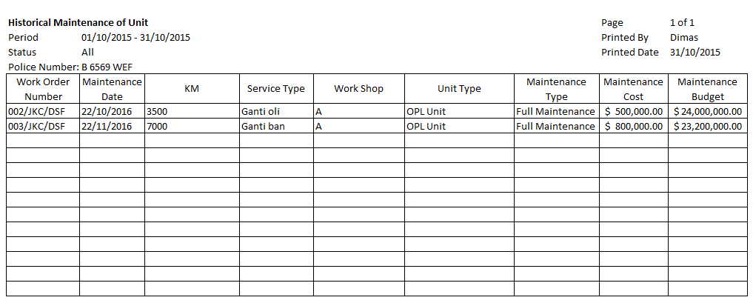

16

5

4

3

2

1

6

15

14

13

12

11

10

9

8

7

* 1. Entity Relationship Diagram

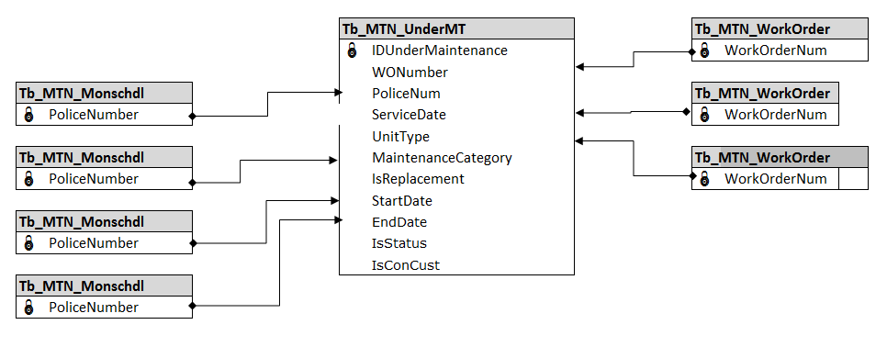

**APPENDIX**

Configuration Access for Monitor Under Maintenance of Unit:

|  |  |  |  |  |  |  |  |
| --- | --- | --- | --- | --- | --- | --- | --- |
| **User** | **Branch** | **Functions** | | | | | |
| **Display List** | **Create** | **Edit** | **View** | **Print Form** | **Print Report** |
| PIC Maintenance HO/Branch | One | V | V | V | V | V | V |
| Area |  |  |  |  |  |  |
| All |  |  |  |  |  |  |
| Marketing Officer | One | V |  |  | V | V | V |
| Area |  |  |  |  |  |  |
| All |  |  |  |  |  |  |
| Head of Branch | One | V |  |  | V | V | V |
| Area |  |  |  |  |  |  |
| All |  |  |  |  |  |  |
| Head of Department | One |  |  |  |  |  |  |
| Area |  |  |  |  |  |  |
| All | V |  |  | V | V | V |
| Regional Manager | One |  |  |  |  |  |  |
| Area | V |  |  | V | V | V |
| All |  |  |  |  |  |  |
| Advisor | One |  |  |  |  |  |  |
| Area |  |  |  |  |  |  |
| All | V |  |  | V | V | V |
| Director | One |  |  |  |  |  |  |
| Area |  |  |  |  |  |  |
| All | V |  |  | V | V | V |
| President Director | One |  |  |  |  |  |  |
| Area |  |  |  |  |  |  |
| All | V |  |  | V | V | V |
| Shareholder's Meeting | One |  |  |  |  |  |  |
| Area |  |  |  |  |  |  |
| All | V |  |  | V | V | V |
|  |  |  |  |  |  |  |  |
| **Legend:** |  |  |  |  |  |  |  |
| V = Have the access |  |  |  |  |  |  |  |